Gurpreet Longia

1. As you increase the dielectric of the surroundings, the peak shifts to the right, increasing wavelength. There is also a slight increase the absorbance.

The dielectric of water is 1.33.

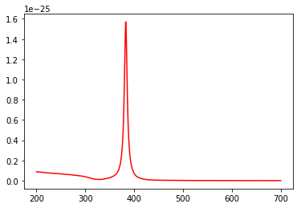

The dielectric of glass is 1.45.  
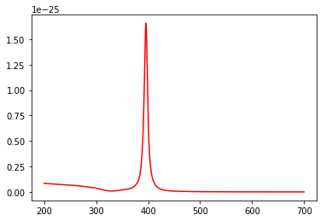

The dielectric of alumina is 1.76.

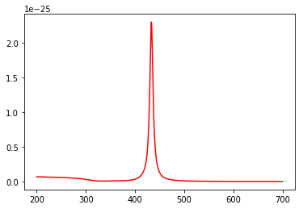

1. As you decrease the dielectric of the surroundings, the peak shifts to the left, decreasing the wavelength and the absorbance.

The dielectric for air 1.0.

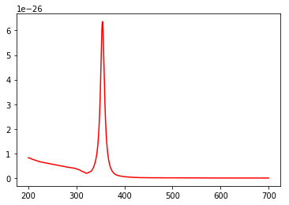

The dielectric for water is 1.33.



This is the spectra for Au.

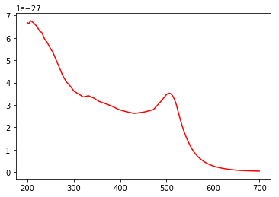

This is the spectra for Ag.



The Ag spectra shifts to the left compared to Au. There are also 2 peaks seen for the Au spectra.

This is the spectra for Ag in water, the blue part is the real part and the red part is the imaginary part.

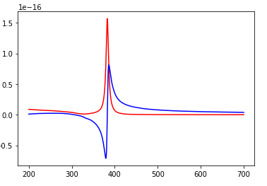

As seen in the spectra, the imaginary part of the spectra is positive and the real part is negative. The imaginary part has a higher absorbance.

This is the spectra for Au in water, the blue part is the real part and the red part is the imaginary part.

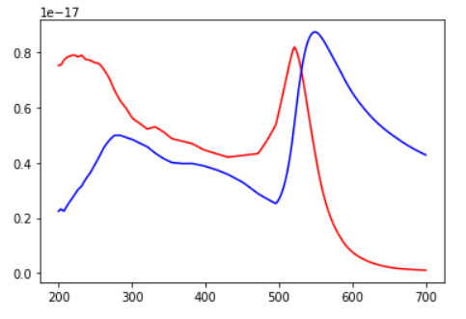

As seen in this spectrum, the real part shifts to the right as compared to the imaginary part. The real part also has slightly higher absorbance.